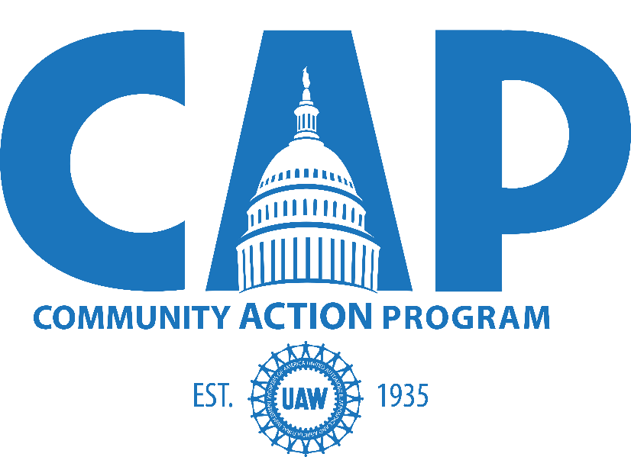

2018 UAW National CAP Conference
Washington, DC
February 4-7

Table of Contents

Schedule | Page 2
Eligibility | Page 3
Registration Fees | Page 3
Registration Deadlines | Page 3
Online Registration and Credentials | Page 4
Hotel Reservation Information | Page 4
Airline Reservation Information | Page 5
V-CAP Sales Booth | Page 5
Expense Guidelines | Page 6
Tuesday Reception | Page 6
V-CAP Sales Booth Application Form | Page 7

SCHEDULE

Location |  | Date | Arrival and Registration
Marriott Wardman Park  2660 Woodley Road, NW  Washington, DC 20008  (202) 328-2000 |  | Sunday, February 4  through  Wednesday, February 7 | Saturday & Sunday  February 3 & 4
Tentative Schedule

Saturday  February 3 | Early Registration  1:00 – 5:00 p.m.
Sunday  February 4 | Registration  9:00 a.m. - 4:00 p.m.  Opening Plenary Session  4:30 p.m.  (Ballroom doors open at 4:00 p.m.)
Monday  February 5 | Plenary & Workshop/s
Tuesday  February 6 | Regional Breakfasts  Lobby on the Hill  Reception
Wednesday  February 7 | Closing Plenary Session  Note: please arrange travel for  after 2 p.m.

ELIGIBILITY

Attendance to the 2018 National CAP Conference will include delegates, distinguished guests of the Officers and Regional Directors, and spouses/companions of delegates. All distinguished guests must be approved by the respective Officer, Regional Director and the President of the International Union.

REGISTRATION FEES

Registration for the 2018 National CAP Conference will take place online. Payment for registration fees will be submitted through the mail to the National CAP Department. After December 15 there will be no refunds given for cancelled registrations. Local unions or CAP Councils may replace delegates until January 5, 2018. All delegates must be approved by their Regional Director. LOCAL UNIONS AND CAP COUNCILS MAY NOT SEND ANOTHER MEMBER OF THEIR LOCAL UNION OR CAP COUNCIL AS A SPOUSE/COMPANION TO AVOID THE $300 DELEGATE REGISTRATION FEE.

DELEGATE AND DISTINGUISHED GUEST REGISTRATION FEE

The registration fee for each delegate and distinguished guest is $300.

SPOUSE/COMPANION REGISTRATION FEE

The registration fee for each spouse or companion is $125.

Please make checks payable to: International Union, UAW
Mail to: UAW National CAP
8000 E. Jefferson Ave.
Detroit, MI 48214

REGISTRATION DEADLINE

We strongly encourage members to register before December 15, 2017 (although participants can continue registering until the start of the conference, subject to approval of the Regional Director). As always, rooms are limited and available on a first-come, first-served basis. After December 15, there will be no refunds given for cancelled registrations. Local unions or CAP Councils, however, may replace delegates (pending approval from the Regional Director) until January 26, 2018.

ONLINE REGISTRATION AND CREDENTIALS

An online credential application must be filled out for each delegate, spouse/companion and distinguished guest attending the conference. All applications for credentials will be filled out online (everything is case sensitive) at:

https://cap.uaw.org
Username: CAP2018
Password: UAWCAP

Applications can be filled out by the applicants, officers or staff of the local union or CAP Council.

If a delegate or local is unable to register online, please call 313-926-5531.

HOTEL RESERVATION INFORMATION

ONLINE REGISTRATION

All delegates, distinguished guests and spouses/companions must register their own rooms via the link provided by the Marriott Wardman Park Hotel (available on https://cap.uaw.org) or by calling 202-328-2000. All hotel reservations and cancellations are the responsibility of the respective conference delegate. Reservations are made on a first-come, first-serve basis. The UAW-negotiated rate is $199 per night plus applicable taxes and fees. Hotel check-in time is 4 p.m.; check-out is 12 p.m.

AIRLINE RESERVATION

INFORMATION

TRANSPORTATION

Conference attendees are responsible for making their own travel arrangements, and the cost of the airline reservation is the responsibility of the local union or CAP Council. Arrangements can be made through TSI (Travel Solutions International) by e-mail at uaw@tsiusa.com or by telephone 866-397-0667. Identify yourself as an attendee at the National CAP Conference in Washington, DC.

Local unions may also use the online reservations process. To enroll your local union in this process, go to www.coordinatedtravel.com.

We have discounted rates for travel from the airports to the hotel via Super Shuttle (http://www.supershuttle.com/).
GROUP: UAW CAP Conference
HOTEL: Marriott Wardman Park (Washington, DC)
DISCOUNT CODE: WPHNQ
DISCOUNT VALID DATES: February 1-10, 2018

V-CAP SALES BOOTH

All UAW locals and CAP Councils will be able to sell their merchandise during the 2018 National CAP Conference. They will be allowed one eight-foot table for sales.

The application to have a V-CAP sales booth is attached as an addendum. Locals or CAP Councils must complete the form and submit it to their Regional Director for approval. Once approved, the Region will forward the form to the National CAP Department.

EXPENSE

GUIDELINES

FINANCIAL ARRANGEMENTS

Lost time, transportation, hotel costs and the $300 delegate registration fee will be paid by participating Local Unions, CAP Councils, outside organizations and, where appropriate, from retiree regional funds. Four meals will be provided and should be deducted from any per diems: Sunday dinner, Monday lunch, Tuesday breakfast and Tuesday dinner.

The sponsors of distinguished guests will be responsible for the $300 registration fee, unless passed on to the distinguished guest.

Adherence to these financial guidelines will expedite the registration process at the conference and in some cases, prevent issues at the CAP Conference registration desk.

TUESDAY RECEPTION

We encourage you to contact your legislators and invite them to attend a reception on Tuesday, February 6. The purpose of this event is for our delegates to share an evening with their congressional leadership. Therefore, if a Congressperson cannot attend, it is not necessary for them to send aides or staff for representation.

rc/opeiu494

