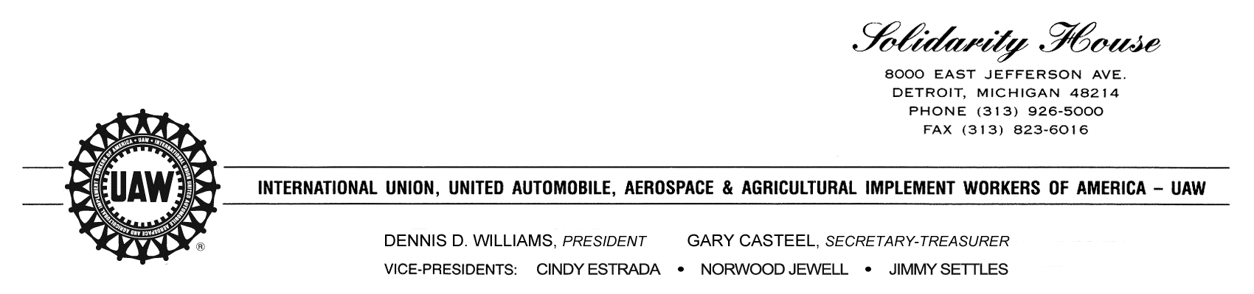

June 28, 2017

Dear Local Union Presidents:

This year’s Labor Council for Latin American Advancement (LCLAA) National Latino Workers Conference and 45th Anniversary Event will be held in Washington, DC, September 6-7, 2017.

To register for the conference and the hotel, go to [www.lclaa.org](http://www.lclaa.org). Early bird registration must be received by **July 14.** In order to receive the LCLAA Convention rates, the deadline for delegates to make their hotel reservationsis **August 14** at the W Washington D.C.

Thank you for your participation, and I look forward to seeing you in Washington.

In solidarity,

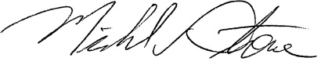

Mike Stone, Director

UAW Civil and Human Rights Department

MS/rc

opeiu494

